# Blender Tutorial (Donut)

## Useful Key bindings

Move an object

G

To snap it to an axis while moving

X, Y or Z, or hold middle mouse

To stop this process

esc

This is the same for rotation/scaling

To navigate with the camera, these will come in handy

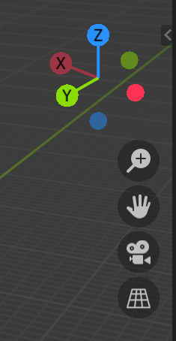

To focus on an object

`+3

To delete an object

X + Enter

To add an object

Shift + A

To find an action for something (and the hotkey!)

F3

# Blender Tutorial (3d printing professor)

## Navigating the View

No need to press ~+8 or whatever to get to a certain view, you can just click this

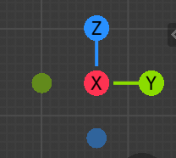

## Movement

# Another tutorial

When you want to use measurements when positioning a loopcut:

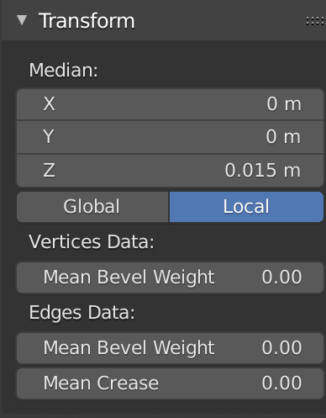

We can extrude faces/edges by pressing E

Box deselect:

* Press B to draw a box
* Select them all
* Hold shift while unselecting

Turn on snapping to make life easier

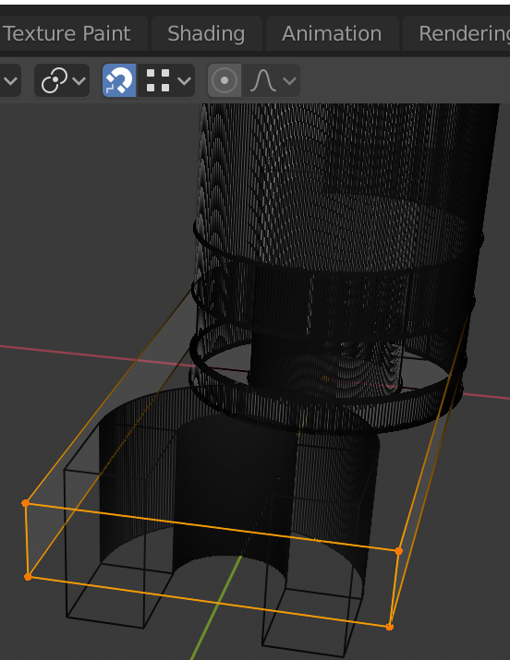

To change units

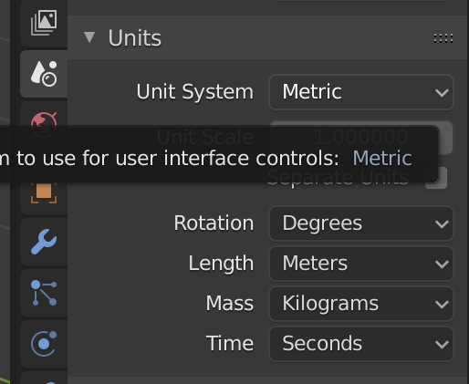

‘snap cursor to selected’ to move cursor to a spot

Snap selected to cursor

I can check if my model is broken before exporting it! Mesh Analysis

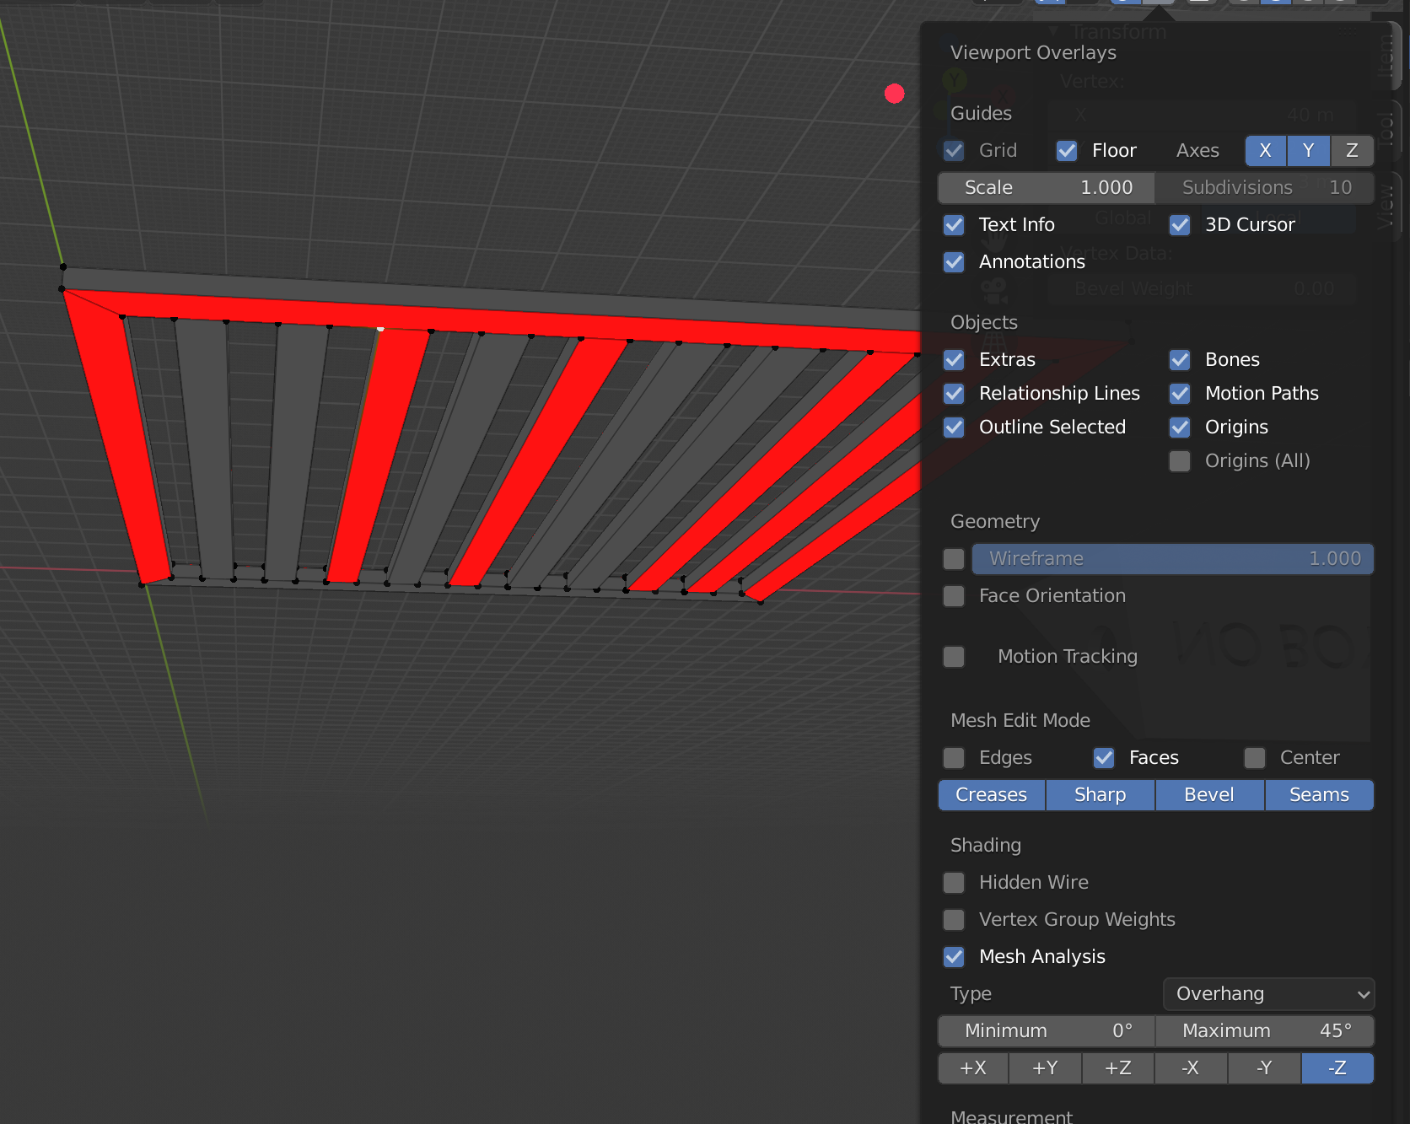

Remove by doubles = Merge by distance. Set the threshold small and try it

Use Shift+N to recalculate normals, that can help

We can add a 3d print toolbox for more help

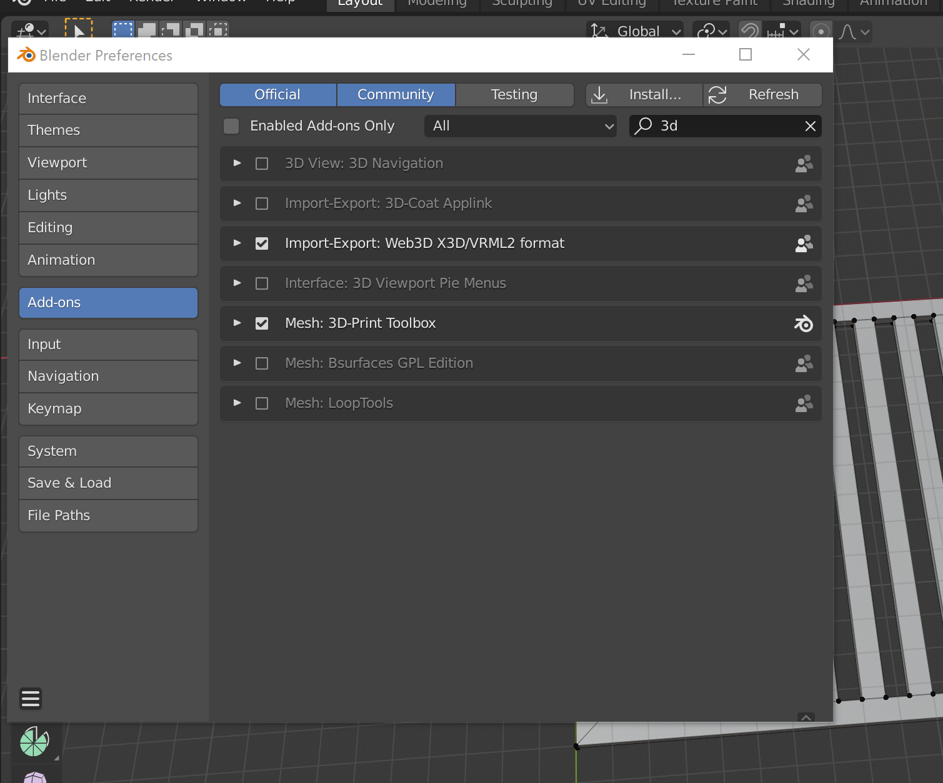

Fixed it by doing this and deleting faces

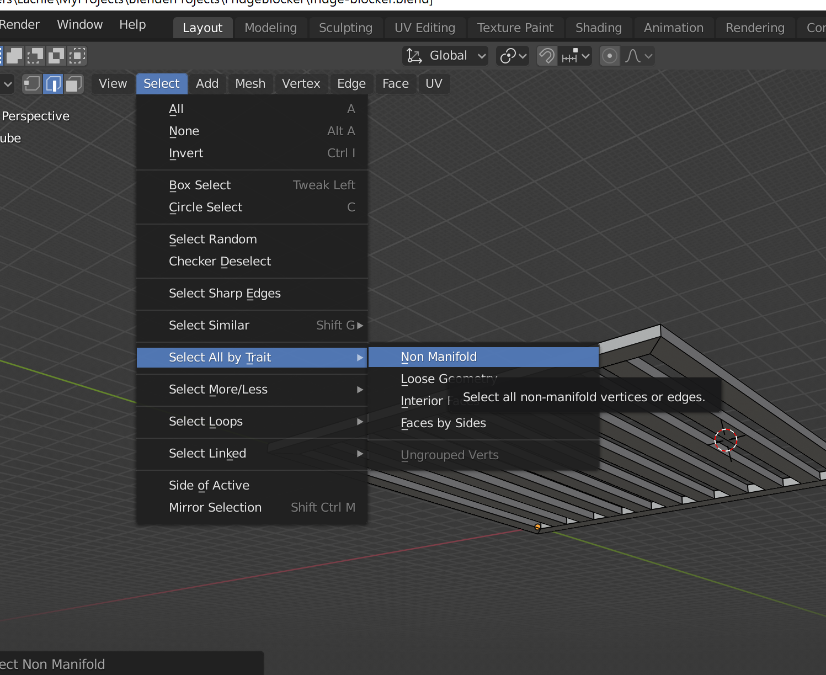

Oh shit I can choose which problems to identify

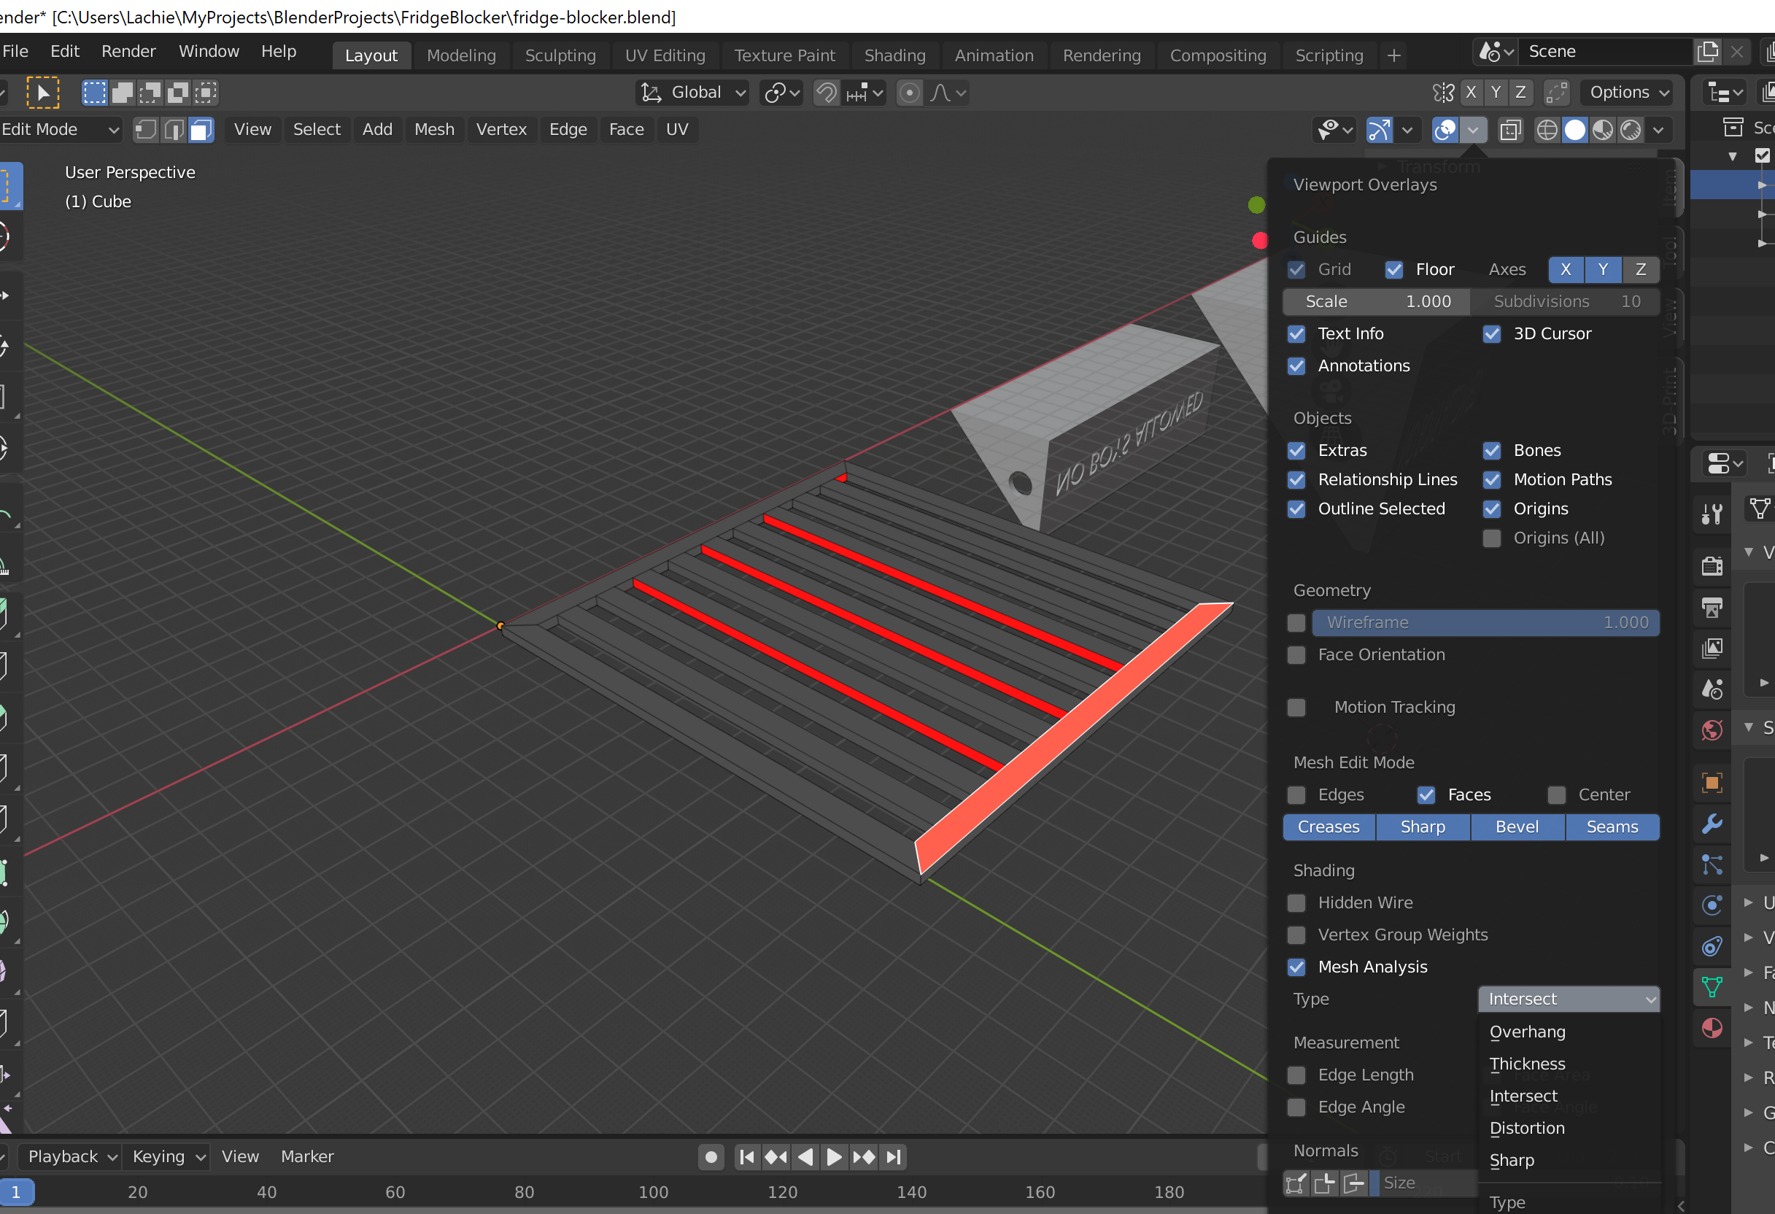

<https://all3dp.com/2/non-manifold-edges/>

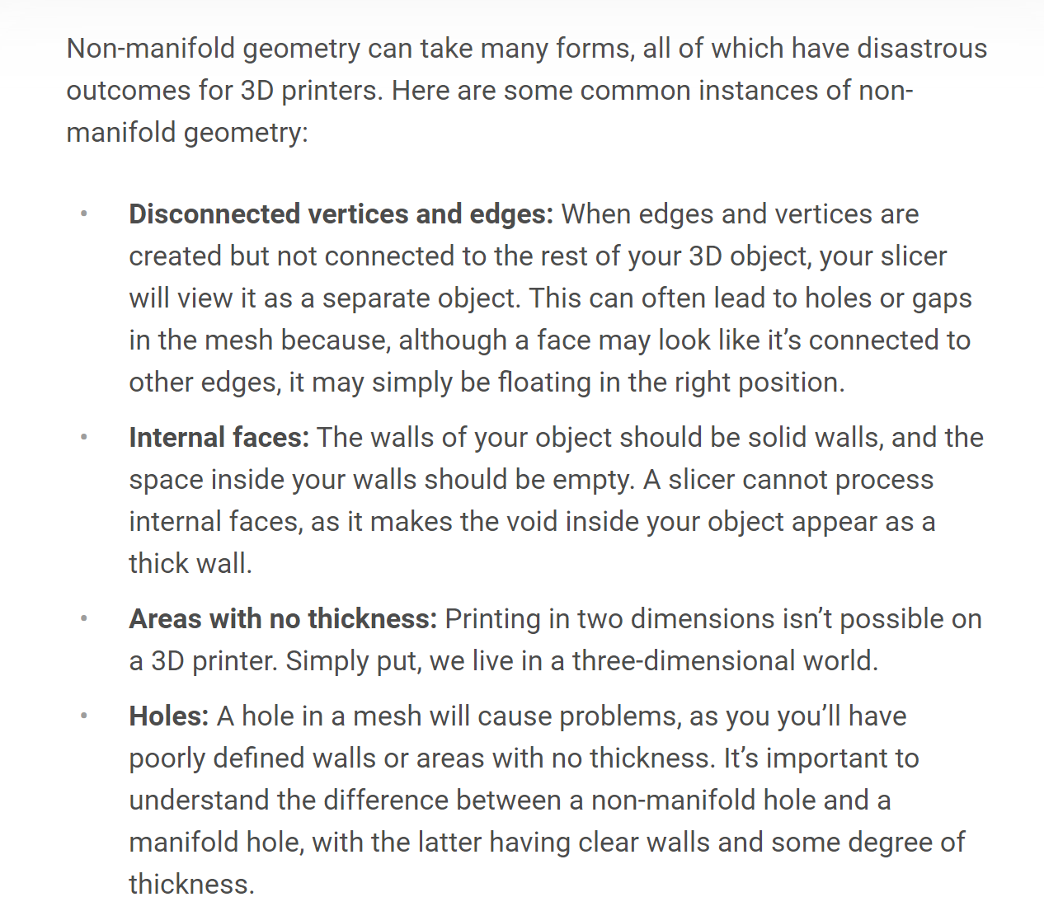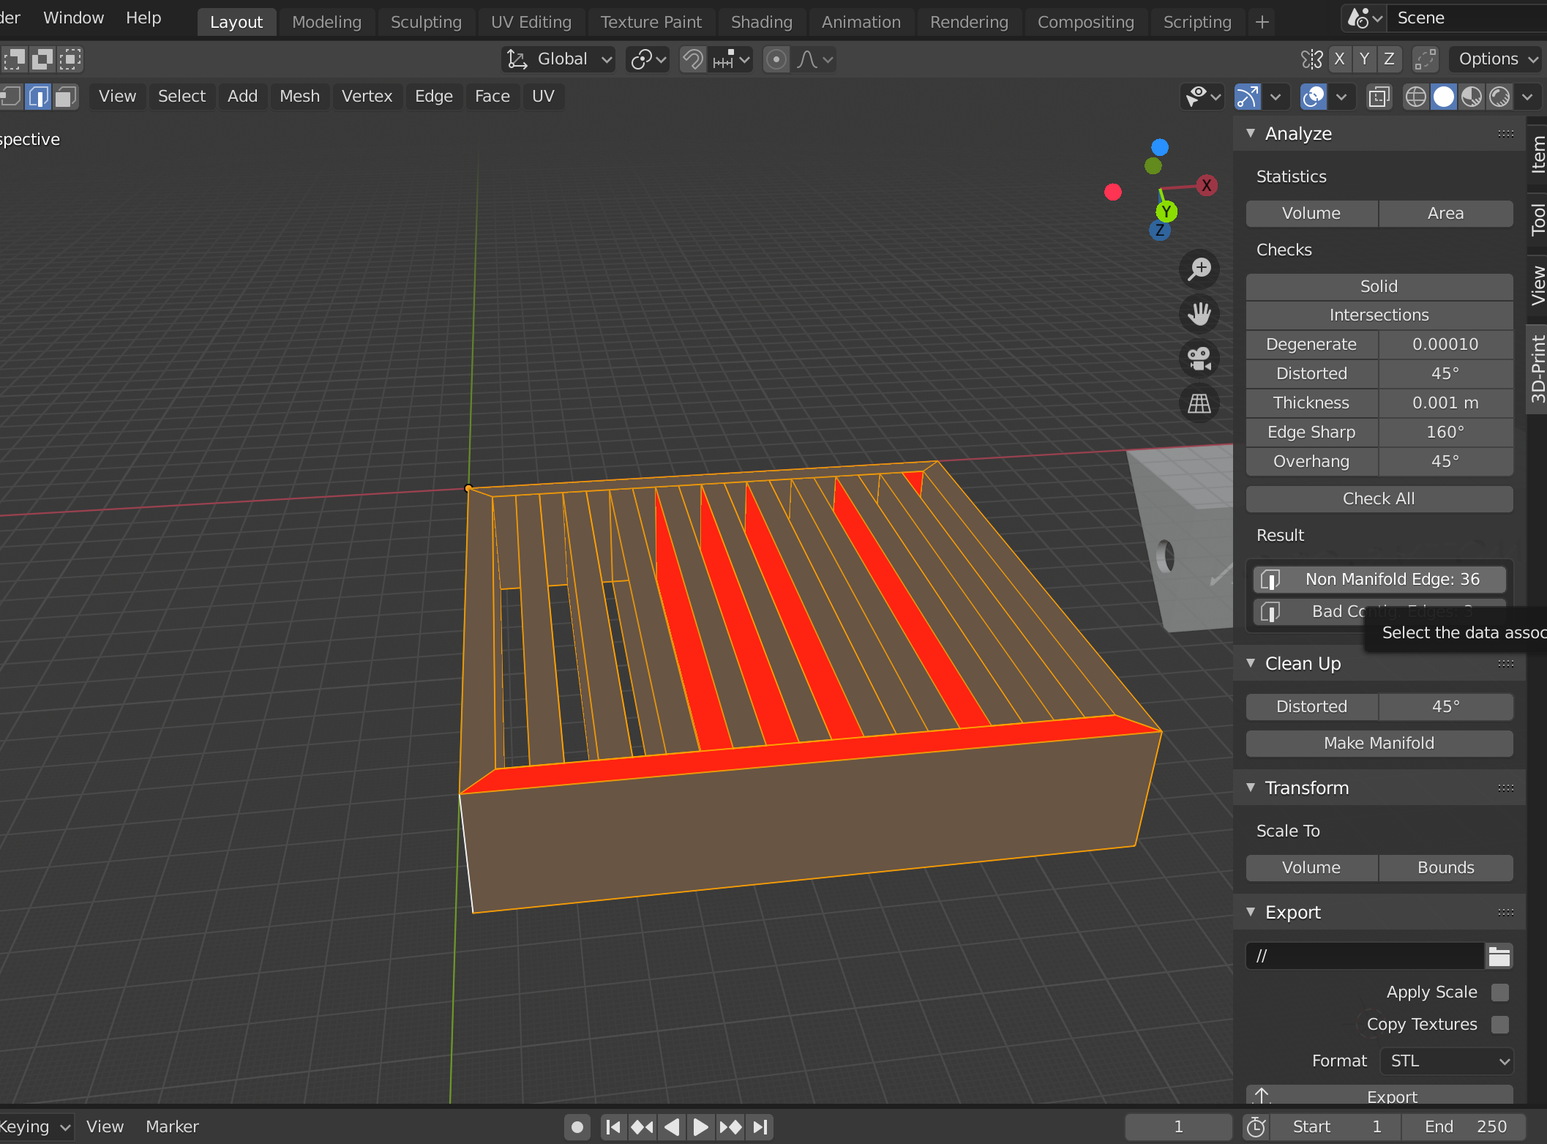

I think my Benchy stringing issues are because I don’t have enough retraction. To change this setting, you need to enable Expert Mode in FlashPrint.

